What is important to Taylor | About Taylor  I am originally from the Cincinnati area.  I am married to my husband Tyler (pictured with Conner below).  I am an agent with New York Life.  I also run a small business making wigs to help people with hair-related illness.  I enjoy spending time outside, gardening, and kayaking.   |  |  | How we can best support Taylor
My family  My friends  My community  My dog, Obi  My brother, Conner (pictured with me below)  Quality time  Being a resource to others  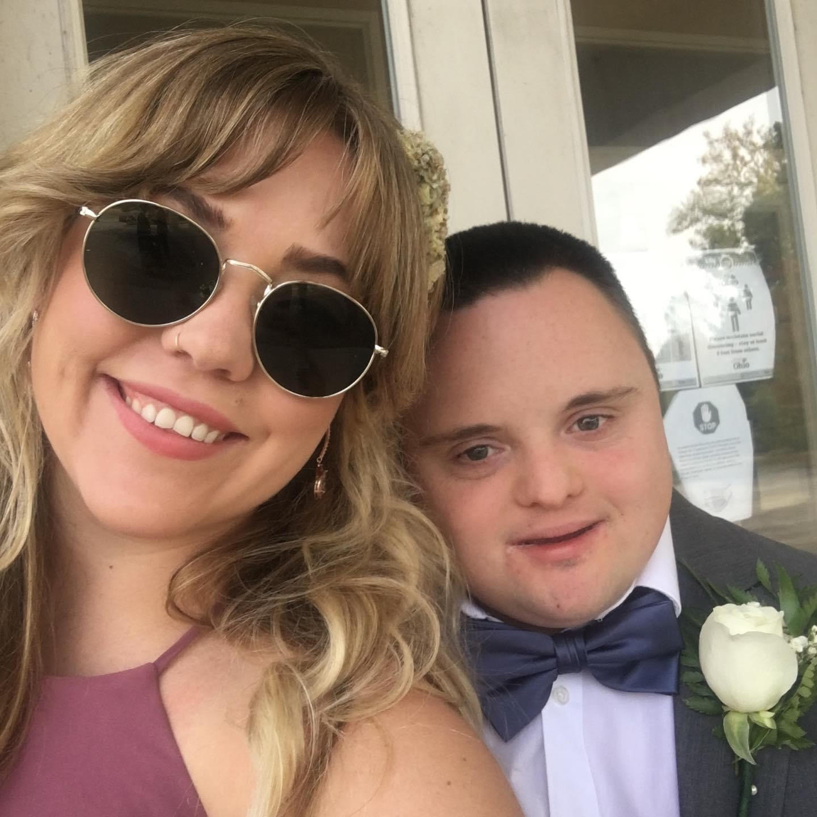 |  |  |  | Ask me about my work!  Take the time to get to know me, and I’d like to get to know you!  
 |  | What those who know Taylor say they like and admire best about Taylor:
My sense of humor

My work ethic

That I am compassionate

I am honest and openminded

Taylor Malott
Taylor Malott
Agent, New York Life Insurance Company

Colorado General Office
3003 E Harmony Rd. Suite 110
Fort Collins, CO. 80528
Cell: 513-237-8994
Email: tmmalott@ft.newyorklife.com

